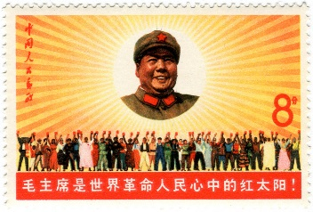
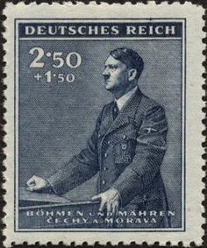
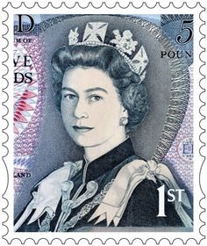
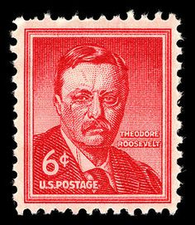
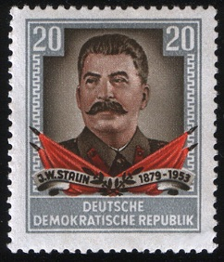

New Jersey Institute of Technology
The 20th Century World-Honors
Fall Session 2017
Course Syllabus

Instructor: Professor Scott L. Kent
Email: kent@njit.edu
Office: Room #331 Cullimore Hall
Office Hours:*
Mondays thru Fridays: 9:00am to 3:45pm by appointment
*additional evening hours by appointment

HIST 213-H01 meets Tuesdays and Thursdays from 4:00pm to 5:25pm in Kupfrian Hall room #118

Course Description:
In this course we shall use case studies to provide an inter-disciplinary view of the 20th century world. Selected cultural, literary, philosophical, and artistic movements are discussed in the context of major historical developments of the century. This course satisfies three credits of the GUR in Cultural History. Prerequisite to this class is HUM 102.
General Education Goals:
Hist 213 is affirmed in the following General Education Foundation Category: Historical Perspective. The corresponding General Goal is as follows: Students will understand historical events and movements in the world, both Western and non-Western, and assess their subsequent significance.

Course Objectives:
Knowledge of history is of the greatest importance due to the fact that the world we live in today is the direct result of various historical developments. The students of the course will analyze historical events and movements of the 20th century and assess their subsequent significance. Students will use critical thinking and problem solving skills to analyze information and develop their writing skills by producing a historically themed research paper. Additionally students will learn how to synthesize historical and geographical information acquired through the understanding of maps and primary source information.
Course Goals:
Upon completion of this course, students should specifically be able to do the following:
- Demonstrate knowledge of some of the fundamental concepts and theories of historical events and ideas related to the 20th Century World.

- Evaluate global exchanges and perspectives in context of social, political, religious, and intellectual traditions.

- Read, analyze, organize and synthesize, evidence, historical problems, and interpretations connected to the history of the 20th Century World.

Measurable Course Performance Objectives (MPOs):
Upon successful completion of this course, students should specifically be able to do the following:
- Demonstrate knowledge of some of the fundamental concepts and theories of historical events and ideas related to human societies, including but not limited to Africa, India, China, Latin America, Europe, and the United States.

  - Identify and describe key terms, names and places of major events of the 20th Century World.

  - Evaluate the validity of various interpretations of historical events and institutions.

  - Clarify and summarize information pertaining to historical events and ideas in a Research Paper.

- Evaluate global exchanges and perspectives in context of social, political, religious, and intellectual traditions.

  - Identify places and nation states on historical maps.

  - Discuss social structures, religious ideas and institutions, and intellectual traditions.

- Read, Analyze, organize, and synthesize evidence, historical problems, and interpretations connected to the history of the 20th Century World

  - Use primary and secondary sources to show how historical problems are confronted.
  - Conduct research and explore reliable resources on the history of the 20th Century World

Methods of Instruction:
Instruction will consist of lectures, visual aids, class discussion, and the viewing of films and documentaries.

Required Textbooks:
Findley, Carter and Rothney, John Alexander. Twentieth Century World Sixth 0r Seventh Edition. (Seventh Edition is now available) Houghton Mifflin Company: Boston Mass., 2006. ISBN: 9780618522637
Gilbert, Martin. The First World War, A Complete History. Henry Holt and Company: New York New York, 1994. ISBN: 0-8050-4734-4
Suggested Reading:
Achebe, Chinua, Things Fall Apart, 50th Anniversary Edition. Anchor Books: New York New York, 1994. ISBN: 0-385-47454-7

Primary Source Literature:
Selected Primary Source Readings by: Otto von Bismarck, Heinrich Treitschke, Woodrow Wilson, Nikolai Bukharin, Evgeny Preobrazhensky, Adolf Hitler, Mao Zedong, Ruhollah Khomeini, Ho Chi Minh, Eva Peron, Mohandas Gandhi, Ronald Reagan, and Harry S. Thurman. (Provided by the Instructor on Moodle)
Course Requirements:
One Research paper- 7-8 pages in length valued at 25%
Examinations- mid-term and final valued at 20% each 40%
Reaction Paper at 10% 10%
Pop-quizzes –at least two valued at 5% each 10%
Map Tests- two valued at 2.5% 05%
Attendance/ Class participation valued at 5% each 10%
100%

Exam Policy:
Mid-term and final exam will be given only during scheduled times. The one exception being that the final may be rescheduled if the student has three exams scheduled on the same day. See me before the day of your exam.

Grading:
- 90-100% Superior Work: demonstrates excellent writing, analytical, and interpretive skills.

- 80-84% Above Average Work: demonstrates good writing, analytical, and interpretive skills

B+- (same as above but with a score of 85 -89%)

- 70-74% Average Work: demonstrates writing, analytical, and interpretive skills that are at a college entry level.

C+ (same as above but with a score of 75-79%)

- 60-69% Below Average Work: demonstrates writing, analytical, and interpretive skills that are below a college entry level.
F- Below 60% Failure: work that shows little effort or that is incomplete.

Attendance:
Attendance is required and attendance will be taken at the start of every class. Each student is permitted Three absences during the semester. Additional absences will affect the student’s grade. Unexcused lateness counts as ½ of an absence. Leaving class early also counts as ½ of an absence. The Attendance Policy will be explained in detail on the first two days of class. Any student with more than Five (5) absences will have their grade lowered by a full letter grade which could result in an “F” for this course.
Cell Phone Usage:
Cell phone usage will not be tolerated. Phones must be turned off or placed on vibrate before the beginning of class. Texting during class is also strictly prohibited.
Class room Decorum:
There shall be no food or eating in the class room. Rude or obnoxious behavior will not be tolerated, the student will simply be asked to leave the class.

Lap Top Usage:
Lap tops are not to be used during class, unless they are used for taking class notes. If this is the case please sit in the front two rows of the class room and see me for permission prior to using your lap top.
Academic Integrity:
Plagiarism is passing off someone else’s work as your own and will not be tolerated. Students are expected to write their own original work and to give credit in the form of footnotes (i.e. citations) for any material that is not their own. Plagiarized papers will be given an automatic “F” with no possibility of a rewrite. This may result in a failing grade for the entire course. Violations will be brought to the immediate attention of the Dean of Students and adjudicated in accordance with the NJIT Honor Code. A copy of the Honor Code is available at www.njit.edu/academics/honorcode.php.
Schedule of Assignments:*
Week of |  |  | Assignment
September ,5th |  |  | The 20th Century in World History introductions  Review Course Syllabus,  Review “how to write a college research paper”,  Review Term paper assignment,  Findley: chapter #1 (in class discussion)  Map review- “Europe”
September, 12th |  |  | Origins of the New Century  Read Findley: Chapter #2  Read Gilbert: Chapters #15-26  Reading: “Memoirs” by Otto von Bismarck  (1899)  Reading: “German History in the Nineteenth Century” by Heinrich Treitschke (1915-1919)  Movie “All Quiet on the Western Front “ (part one)
September,19th |  |  | World War One  Read Findley: chapter #3  Reading: “The Fourteen Points” by Woodrow Wilson  Submit one page research paper outline  Reaction Paper Due* Topic: How did the Central Powers go from the verge of triumph in 1917 to total collapse just one year later?  Movie “all Quiet on the Western Front” (part two)
September 26th |  |  | The Bolshevik Revolution in World Perspective  Read Findley: chapter #4  Reading: : “The ABC of Communism” by Nikolai Bukharin and Evgeny Preobrazhensky (1919)  Map Test #1- Europe
October, 3rd |  |  | Global Economic Crisis: The Great Depression and the 1930’s  Read Findley: chapter #5  Watch “The crash of 1929’  Receive Midterm review guide
October,10th |  |  | Fascism and the Road to War  Read Findley: chapter #6  Readings: “Mein Kampf” by Adolf Hitler(1923), “Last Will and Testament” by Adolf Hitler (1945)  Watch “The Nazis, A Warning from History”
October,17th |  |  | Latin America and Sub-Saharan Africa Under European Sway  Read Findley: chapters #7 & 8  Reading: “History of Peronism” by Eva Duarte de Peron (1951)
Asia Struggles for Independence and Development
Read Findley: Chapter #9
Reading: “Hind Swaraj (Self Rule)” by Mohandas K. Gandhi (1909)
MIDTERM EXAM

October,24th
October, 3ist. |  |  | World War Two: The Final Crisis for European Global Dominance  Read Findley: chapter #10
November, 7th  *Last week to drop a class* (11/06/17) |  |  | The Cold War  Read Findley: chapter #11  Reading: “The Truman Doctrine” by Harry S. Truman (1947)  Watch ”The Atomic Café”
November,14th |  |  | Uncertain Progress: The 1970s and 1980’s  Read Findley: chapter #12  Reading: “The ‘Evil’ Empire Speech” by Ronald Reagan (1982)  *Research papers due*
November, 21st  Thursday Classes meet on 11/21 |  |  | Independence for the Developing Countries  Read Findley: chapters #13 and #14  Reading “The Vietnamese Declaration of Independence” by Ho Chi Minh (1945)  Map Review- “The Middle East’
Thanksgiving Break 11/23 to 11/26
November,28th |  |  | The Middle East Since World War two  Read Findley: chapter #15  Reading: “Message to the Pilgrims: by Ruhollah Khomeini (1980)  Receive final exam review guide  Map test #2-The Middle east
December, 5th |  |  | Asia Since World War Two  Read Findley: chapter #16  Reading: “Fighting for Perpetual Peace” by Mao Zedong (1938)  Watch :” the Great Leap, Communism in China 1949-1977”
December12th  Last Day of Class 12/12/17 |  |  | Prospects for the 21st Century  Read Findley: Chapter #18  Final Exam map review.  Last Week of Class
December 15th to 21st |  |  | Final Exam Week: Date T.B.D.  Research Papers Returned  Grades due by December23rd

*Schedule subject to change

